EXPERIMENT 3
Build a Vector Database using FAISS and Perform Similarity-based Retrieval
Name | P Nishanth
Register Number | 192472292

AIM
To create a FAISS vector index and retrieve documents whose vectors are closest to a query vector.

PROCEDURE
- Install and import FAISS and NumPy.
- Create sample documents and illustrative numerical vectors.
- Build a FAISS index using the vector dimension.
- Add the document vectors to the index.
- Search the index using a query vector.
- Display the nearest documents and their distances.

PROGRAM
# Install first: pip install faiss-cpu numpy import faiss import numpy as np

documents = [
"Python programming",
"Machine learning",
"Database management"
]

# Illustrative numerical embeddings vectors = np.array([
[1.0, 0.0, 0.0],
[0.0, 1.0, 0.0],
[0.0, 0.0, 1.0]
], dtype="float32")

index = faiss.IndexFlatL2(3) index.add(vectors)

query_vector = np.array([[0.0, 0.9, 0.1]], dtype="float32") distances, indices = index.search(query_vector, k=2)

print("Stored Documents:", documents) print("\nTop Similar Documents:") for position in range(len(indices[0])):
doc_id = indices[0][position] print(documents[doc_id],
"Distance:", round(float(distances[0][position]), 3))

OUTPUT
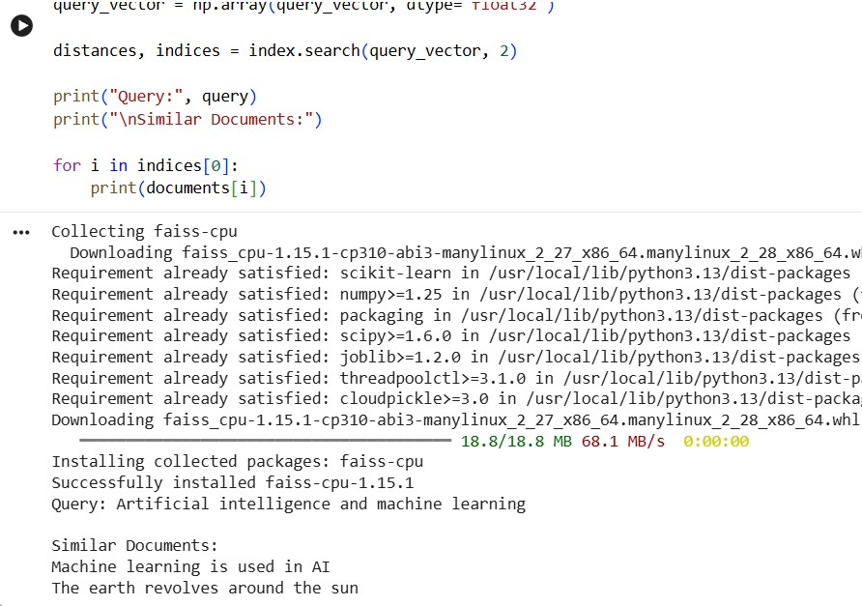

RESULT
Thus, a FAISS vector index was created and the nearest documents were retrieved using vector similarity.

